1. Execute and display the results for the following commands in Kali Linux Operating
Systems:

rm command
users command
tree command

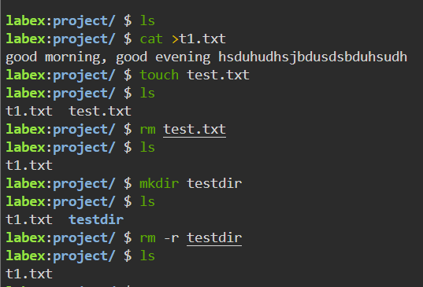

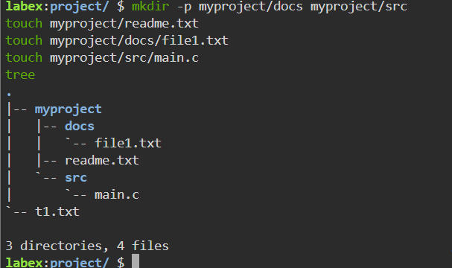

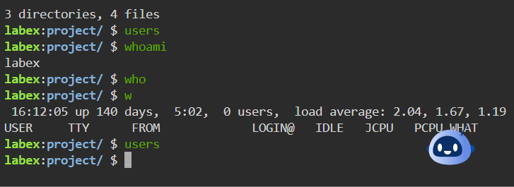

2. Execute and display the results for the following commands in Kali Linux Operating
Systems:

less command
more command
vi command

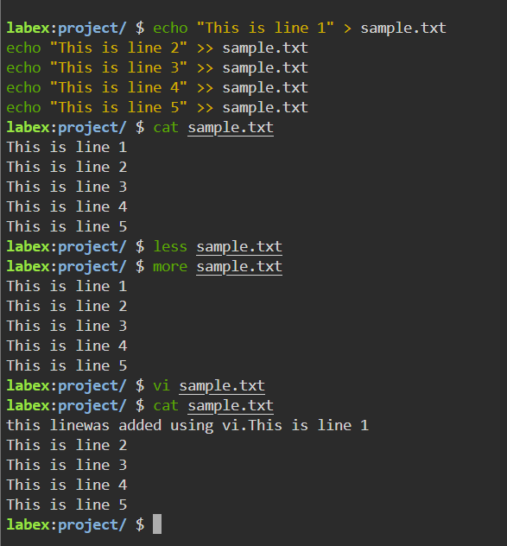

3.Execute and display the results for the following commands in Kali Linux Operating
Systems:

Tree
Head
Tail
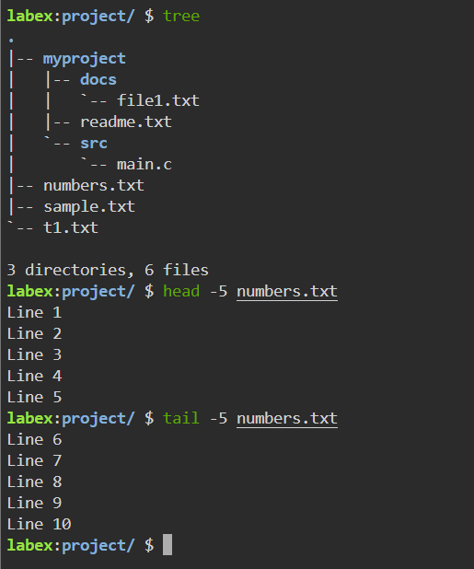

4. Execute and display the results for the following commands in Kali Linux Operating
Systems:
i)
Ls
ii)
Cat
iii)
Mkdir
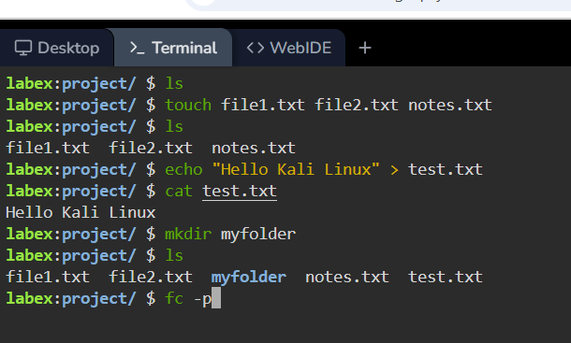

5. Execute and display the results for the following commands in Kali Linux Operating
Systems:
i)
Uptime
ii)
Date
iii)
Mv

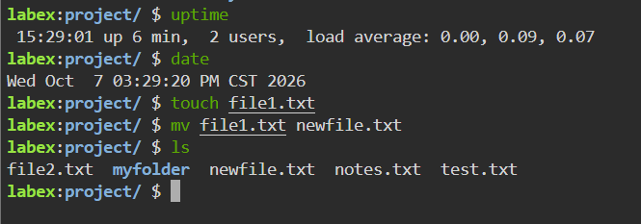

6.Execute and display the results for the following commands in Kali Linux Operating
Systems:
i)
Touch
ii)
Pwd
iii)
Wget

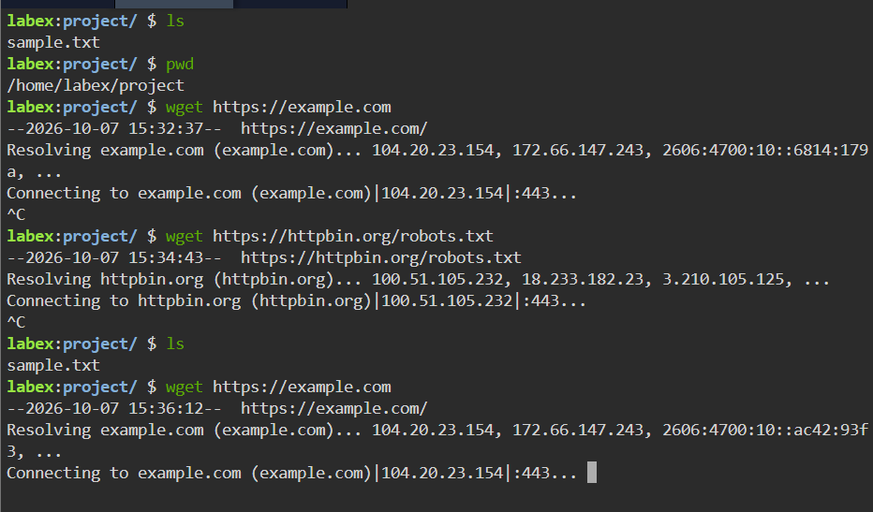

- Execute and display the results for the following commands in Kali Linux Operating
Systems:
Cd
Cp
Ls

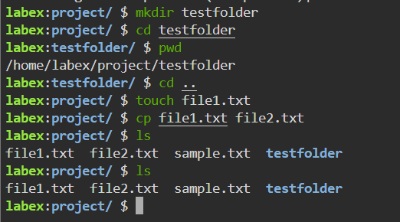

8. Execute and display the results for the following Nmap service version and OS
detection commands in Kali Linux operating systems:
i) detect the version of services running
ii) aggressive scan
iii) detect operating system of the target
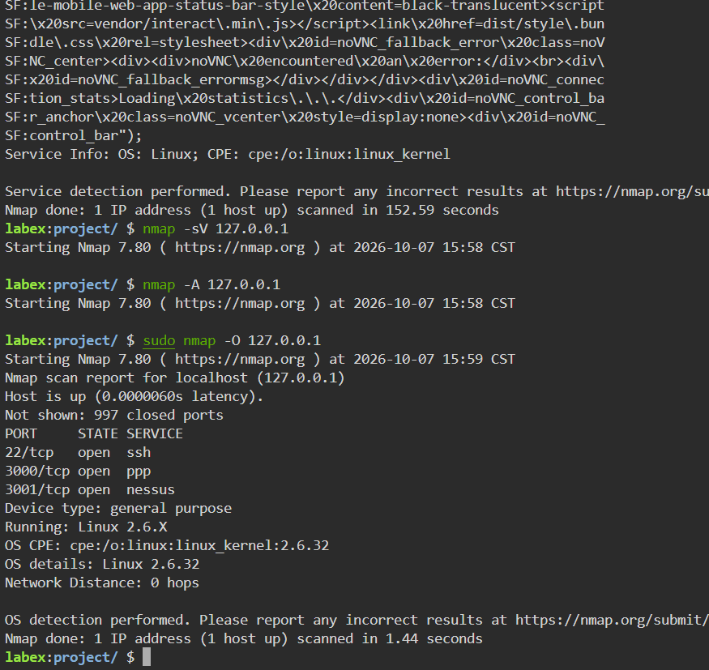

9. Execute and display the results for the following Nmap Timing and performance
commands in Kali Linux operating Systems:
(i) polite IDS evasion
(ii) normal IDS evasion
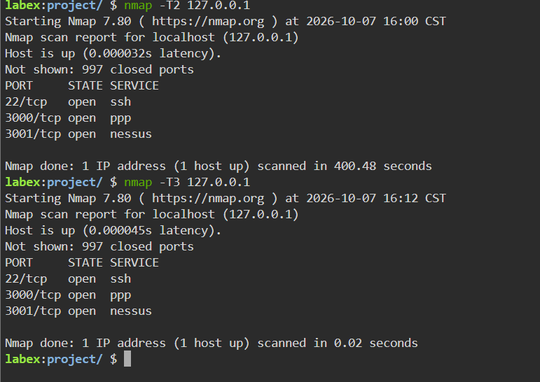

10. To execute the following commands in Kali Linux Operating Systems:
Free command
Sort command
History command
